Rubio Canyon Property Bird Survey
Pasadena Audubon Society
Authors: Lance A. M. Benner and Michael C. Long
2016 September 22

Volunteers from the Pasadena Audubon Society conducted a series of approximately weekly bird surveys on the Rubio Canyon property acquired by the Arroyos & Foothills Conservancy (AFC) from April 7 to June 26, 2016. The purpose of the surveys was to determine species using the property, define breeding birds vs. migrants, determine diversity of species and check for use by any Special Status species. The surveys were coordinated by Lance Benner and Kym Buzdygon (Pasadena Audubon).

Methods:
The area was surveyed by entering the canyon at the top of Rubio Vista Road, going northeast along the main trail into the canyon, taking the trail that switchbacks through chaparral down to the canyon floor, and up the bottom of the canyon for a few hundred yards to the point where the trail forks and one branch climbs into chaparral on the east side of the canyon. Figure 1 shows the route. The surveys also extended down the canyon to the north side of the Rubio Canyon Land and Water Association water tank and along an overgrown road to the east. Originally the route continued for several hundred yards to the south but we abandoned that section due to a major washout in the trail. The route traversed all the major habitats in the area.

Teams of 1-3 observers recorded birds seen and heard anywhere from the route described above. Most surveys were conducted in morning hours, generally starting at about 7:00 a.m., although some started later and earlier, with many lasting about two hours (Table 1). All survey results were entered into the eBird online database (ebird.org) and an Excel data spreadsheet, and a weekly report was sent to all participants.

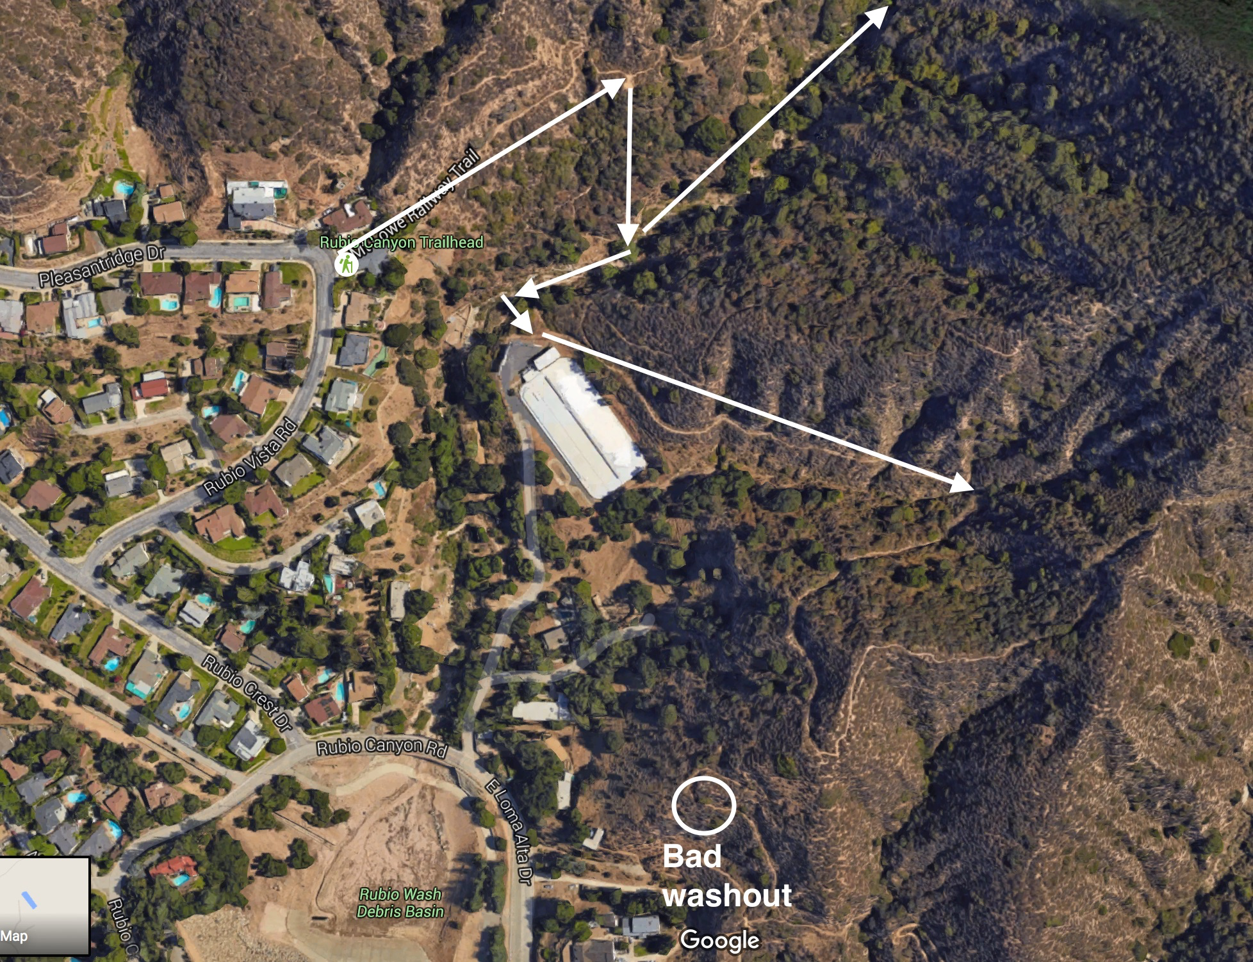
Figure 1: Survey area and route

A total of 14 morning surveys were conducted between April 7 and June 26, 2016 by 11 observers: Lance Benner, Ron Cyger, Darren Dowell, Laura Garrett, Frank Gilliland, Susan Gilliland, Mickey Long, Elaine MacPherson, E.J. Remson, Norm Vargas, and Javier Vazquez. Lance also did four evening surveys that started shortly before sunset and ended after the end of evening twilight, and Darren did one survey before sunrise. The surveys were timed to capture the spring migration and breeding season for most local bird species. Additional bird species are known to use the canyon during fall and winter (through Christmas Bird Count data and previous eBird records) and we almost certainly missed some spring migrants (discussed briefly below).

The evening visits were conducted primarily by listening in an effort to detect owls and other nocturnal birds. The nocturnal surveys used a mixture of passive listening and active audio playback for three species: spotted owl (one survey), western screech owl (one survey), and northern pygmy owl (also one survey). The surveys using playback did not result in detections for spotted and northern pygmy owl but were successful for the first detection of western screech owl. Subsequent evening visits did not play western screech owl recordings. Western screech owl and common poorwill were heard calling spontaneously on multiple occasions. Nocturnal flight calls by Swainson’s Thrush were also heard over the canyon on April 27. During the final survey, Darren Dowell saw two great horned owls in the canyon but outside the survey area to the north, so they have not been included in the totals.

Habitats:
The canyon has four distinct habitats: chaparral; canyon floor with native trees (coast and canyon live oak, California sycamore, bigleaf maple, California bay, white alder); adjacent suburban neighborhoods with many ornamental plants; and various non-native trees (deodars, pines, eucalyptus, palms) near houses by the water reservoir. There were a few small pools of water on the canyon floor when the survey began. By late June the last pool consisted of damp mud.

Results:

Total species found: 85
Number of species found per morning survey: Range: 22-42 Average: 32.1 +- 6.1
Number of individuals found per morning survey: Range: 56-181 Average: 123.7 +- 40.4

Birds found on all 14 morning surveys: (9 species) Mourning Dove, Anna’s Hummingbird, California Scrub-jay, Common Raven, Wrentit, California Thrasher, Northern Mockingbird, California Towhee, and Spotted Towhee.
Birds found on 7+ morning surveys: (28 species) Band-tailed Pigeon, Mourning Dove, White-throated Swift, Anna’s Hummingbird, Acorn Woodpecker, Nuttall’s Woodpecker, Red-crowned Parrot, Pacific-slope Flycatcher, Ash-throated Flycatcher, California Scrub-Jay, American Crow, Common Raven, OaK Titmouse, Bushtit, House Wren, Bewick’s Wren, Blue-gray Gnatcatcher, Wrentit, California Thrasher, Northern Mockingbird, Phainopepla, Wilson’s Warbler, California Towhee, Rufous-crowned Sparrow, Spotted Towhee, Hooded Oriole, House Finch, and Lesser Goldfinch.

Birds detected only once: (27 species) Double-crested Cormorant, Red-shouldered Hawk, Swainson’s Hawk, Rock Pigeon, Vaux’s Swift, Black-chinned Hummingbird, Rufous Hummingbird, Downy Woodpecker, Northern Flicker, American Kestrel, Olive-sided Flycatcher (late in the day), Steller’s Jay, Mountain Chickadee, White-breasted Nuthatch, Red-whiskered Bulbul, Ruby-crowned Kinglet, Western Bluebird, American Robin, European Starling, Cedar Waxwing, Yellow Warbler, Yellow-rumped Warbler, Dark-eyed Junco, Golden-crowned Sparrow, Western Tanager, American Goldfinch, and House Sparrow.

Species confirmed nesting: 15, with an additional 31 species possible to probable based on presence into early summer (late May-late June).

Expected species that we missed:
Sharp-shinned Hawk, Great Horned Owl, Cassin’s Kingbird, Cliff Swallow, Nashville Warbler, Townsend’s Warbler, Hermit Warbler, MacGillivray’s Warbler, Fox Sparrow, Song Sparrow, Lincoln’s Sparrow, Brown-headed Cowbird, and Purple Finch.

We heard and/or saw species in residential parts of Altadena that were not in the canyon itself such as Indian Peafowl, Red-whiskered Bulbul, American Crow, and Red-crowned Parrot.

Notable species:
We found Peregrine Falcon during surveys on three dates: April 15, June 4, and June 26. Darren Dowell saw two multiple times in a four-hour interval on June 26. An additional observation of Peregrine Falcon was reported in eBird by David Hurst (who was not a formal participant in the survey) on April 29. The repeated sightings over nearly three months suggest local breeding.

Several montane species were recorded in small numbers: Mountain Quail, Hairy Woodpecker, Northern Flicker, Steller’s Jay, Violet-green Swallow, Mountain Chickadee, and White-breasted Nuthatch. Although flickers are common in this area in the fall, winter, and early spring, it was unusual to find one at this low altitude on June 26.

The most unexpected species was a single Cedar Waxwing photographed by Darren Dowell on June 26. That is a very late date for this species, which normally migrates north out of this area by mid-May.

Ten Most Numerous Species:
N Species
148 California Towhee
147 Lesser Goldfinch
127 Spotted Towhee
125 House Finch
118 Mourning Dove
105 California Scrub-Jay
88 Anna’s Hummingbird
86 Bewick’s Wren
78 Bushtit
75 Wrentit
The table above gives the cumulative total for each species observed during all the surveys. This is different from the population, which is probably significantly lower.

The survey detected insect eaters, seed eaters, fruit eaters, ground feeders, and foliage gleaners. Diurnal birds of prey were well-represented with six species detected: Cooper’s Hawk, Swainson’s Hawk (migrants), Red-tailed Hawk, Red-shouldered Hawk, American Kestrel, and Peregrine Falcon.

The surveys captured the migration use of the canyon by species like Swainson’s Thrush, which was detected in low numbers on Apr. 27 and May 24. Other migrants detected in small numbers include Vaux’s Swift, Rufous Hummingbird, Olive-sided Flycatcher, Western Wood-Pewee, Cassin’s Vireo, Yellow Warbler, and Lazuli Bunting.

Five species of warblers, three species of vireos, and five species of flycatchers were found during the surveys.

Special Status birds found on the property include a number of species listed as sensitive (Watch List) in Los Angeles County by a working group of field ornithologists. Some are listed due to limited breeding (indicated by “B”) in the County and some were migrants. These include Mountain Quail, Cooper’s Hawk, Common Poorwill, Hairy Woodpecker (lowland), Olive-sided Flycatcher (B), Western Wood-Pewee (B), Hutton’s Vireo, Oak Titmouse, Canyon Wren, Ruby-crowned Kinglet (B), Swainson’s Thrush (B), Hermit Thrush (B), Yellow Warbler (B), Wilson’s Warbler (B), California Towhee, and Black-headed Grosbeak (B).
(L.A. County’s Sensitive Bird Species, L.A. Audubon, Western Tanager, 2009).

The coordinators acknowledge the dedicated volunteer observers who performed the surveys and thank the Arroyos & Foothills Conservancy for encouraging the project.

Table 1: Survey Dates, Times, and Observers
April 7 07:04-08:21 Ron Cyger and Lance Benner
April 14 08:05-11:05 Mickey Long, Laura Garrett, and Elaine McPherson
April 15 08:55-10:25 Lance Benner
April 20 06:52-8:53 Susan and Frank Gilliland
April 22 19:15-19:50 Lance Benner
April 26 07:01-08:54 Ron Cyger, Javier Vazquez, and E. J. Remson.
April 27 19:50-20:55 Lance Benner
May 4 07:01-09:04 Lance Benner and Javier Vazquez
May 10 07:03-09:49 Ron Cyger and Javier Vazquez
May 17 07:12-09:13 Ron Cyger
May 19 08:33-11:03 Mickey Long, Laura Garrett, and Elaine McPherson
May 24 07:02-08:48 Ron Cyger and Norm Vargas
June 4 06:04-08:04 Lance Benner
June 8 19:25-20:40 Lance Benner
June 9 05:36-08:41 Darren Dowell
June 15 06:41-08:21 Lance Benner
June 26 04:28-05:13 Darren Dowell
June 26 05:13-09:23 Darren Dowell
Table 2: Species Recorded
Species #Surveys Species #Surveys
Mountain Quail 4 Bushtit 13 NP
California Quail 5 NP White-breasted Nuthatch 1
Indian Peafowl 6 Canyon Wren 6 NP
Double-crested Cormorant 1 House Wren 16 young
Turkey Vulture 4 Bewick’s Wren 15 NP
Cooper’s Hawk 4 NP Blue-gray Gnatcatcher 12 nest building
Red-Shouldered Hawk 1 Red-whiskered Bulbul 1
Swainson’s Hawk 1 Ruby-crowned Kinglet 1
Red-tailed Hawk 5 NP Wrentit 17 NP
Rock Pigeon 1 Western Bluebird 1
Band-tailed Pigeon 12 NP Swainson’s Thrush 2
Eurasian Collared Dove 2 Hermit Thrush 2
Mourning Dove 18 seen mating American Robin 1
Western Screech Owl 3 Heard mating California Thrasher 17 NP
Common Poorwill 5 NP Northern Mockingbird 18 NP
Vaux’s Swift 1 European Starling 1
White-throated Swift 7 NP Cedar Waxwing 1
Black-chinned Hummingbird 1 NP Phainopepla 10 NP
Anna’s Hummingbird 16 NP
Costa’s Hummingbird 2 NP Orange-crowned Warbler 3
Rufous Hummingbird 1 Yellow Warbler 1
Allen’s Hummingbird 5 NP
Rufous/Allen’s Hummingbird 3 Yellow-rumped Warbler 1
Acorn Woodpecker 11 NP Black-throated Gray Warbler 3
Nuttall’s Woodpecker 15 NP Wilson’s Warbler 7
Downy Woodpecker 1 Dark-eyed Junco 1 young
Hairy Woodpecker 2 NP White-crowned Sparrow 3
Northern Flicker 1 Golden-crowned Sparrow 1
American Kestrel 1 California Towhee 18 nest building
Peregrine Falcon 3 NP Rufous-crowned Sparrow 15 young
Red-crowned Parrot 8 Spotted Towhee 18 young
Olive-sided Flycatcher 1 Western Tanager 1
Western Wood-Pewee 3 NP Black-headed Grosbeak 5 NP
Pacific-slope Flycatcher 9 NP Lazuli Bunting 2
Black Phoebe 5 NP Hooded Oriole 12 NP
Ash-throated Flycatcher 14 NP Bullock’s Oriole 2 NP
Hutton’s Vireo 6 family group House Finch 16 young
Cassin’s Vireo 2 Lesser Goldfinch 15 feeding young
Warbling Vireo 2 American Goldfinch 1
Steller’s Jay 1 House Sparrow 1
California Scrub-Jay 17 young
American Crow 12 NP
Common Raven 17 carrying food; family group
No. Rough-winged Swallow 6 NP
Violet-green Swallow 2 NP
Mountain Chickadee 1
Oak Titmouse 12 young

NP = nesting possible based on occurrence from late May to late June.

